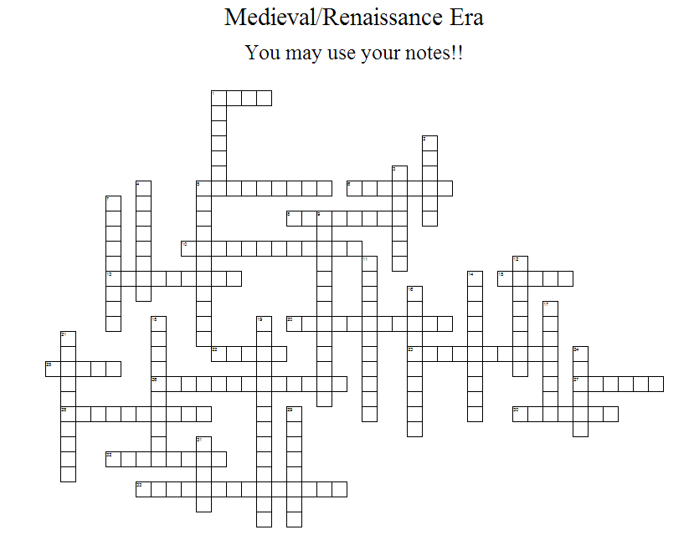
ACROSS
 | 1 | went to prison
 | 5 | famous Baroque painter that used lighting
 | 6 | Italian priest turned composer at St. Mark's
 | 8 | first composer to designate instrument parts
 | 10 | music written for an idea or mood
 | 13 | Founded monastery, mystical powers
 | 15 | Bach's instrument of choice
 | 20 | means "re-birth"
 | 22 | complex, polyphonic, immitative piece Bach wrote based on a subject
 | 23 | Savior of Polyphony - "Prince" of music
 | 25 | standardized musical pitches in the Renaissance
 | 26 | holy leader, didn't like music in 1555
 | 27 | wrote "95 Thesis"
 | 28 | texture - multiple voices moving together
 | 30 | Handel's most famous "Christmas" tune
 | 32 | soloist with full orchestra or band
 | 33 | Handel's outdoor tune with a fire
 | DOWN
 | 1 | Grotesque - deformed pearl
 | 2 | "Cosmopolitan" composer in England
 | 3 | famous Renaissance artist and inventor
 | 4 | Italian composer that loved echos
 | 5 | Lutheran separation from Catholicism
 | 7 | Palestrina used this texture despite the law
 | 9 | Section of Baroque "Bass" instruments who improvised
 | 11 | Name of Vivaldi's violin concerto
 | 12 | a biblical-based piece for choir and orchestra
 | 14 | works for solo cello based on dances
 | 16 | texture - one unison voice
 | 17 | Musical volume invented by Gabrieli
 | 18 | texture - multiple independent voices
 | 19 | met to purge church of unholy things
 | 21 | means "echo" - a means of musical imitation
 | 24 | Vocal style, wrote a 40-part motet
 | 29 | Super-human skill on an instrument
 | 31 | cultural hub during the Baroque era
WORD BANK: VIVALDI, VIRTUOSO, TALLIS, STAFF, ROYALFIREWORKS, RENAISSANCE, REMBRANDT, REFORMATION, PROGRAMMUSIC, POPEMARCELLUS, POLYPHONY, POLYPHONIC, PALESTRINA, ORGAN, ORATORIO, MONOPHONIC, MESSIAH, LUTHER, ITALY, HOMOPHONIC, HILDEGARD, HANDEL, GABRIELI, GABRIELI, FUGUE, FOURSEASONS, DYNAMICS, DAVINCI, COUNCILOFTRENT, CONCERTO, CELLOSUITE, BOSSOCONTINUO, BAROQUE, BACH, ANTIPHONAL

